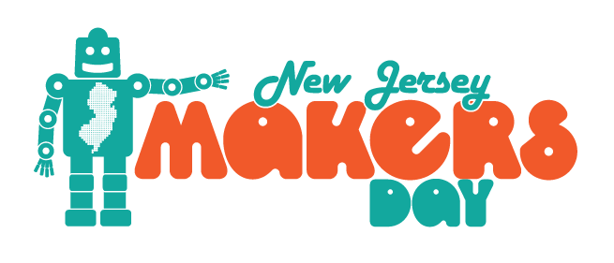

FOR IMMEDIATE RELEASE

Join Us for the Fourth Annual NJ Makers Day
[Date]

[CITY], NJ -- The maker movement in the United States isn’t just a hobby; it’s having a significant impact on school curriculum development and growing local economies. To celebrate making and maker culture, residents throughout New Jersey will come together on Friday, March 9 and Saturday, March 10, 2018 in libraries, schools, museums, colleges, makerspaces, businesses and other community locations.

NJ Makers Day is designed to be a statewide event that celebrates, promotes, and in many cases may introduce maker culture, as well as the values associated with making, tinkering and STEM-based learning. In 2017, NJ Makers Day drew over 85,000 individual attendees to more than 300 participating sites across all 21 counties in the state. Participating locations included schools, colleges and universities, libraries, museums, and other educational organizations.

Makerspaces across the state are having a significant impact on education and job skills development by providing access to people, information, resources, and tools that facilitate making to a wide variety of skill levels. NJ Makers Day allows communities to share hands-on programming opportunities, demonstrations and displays, and the expertise of the individuals and organizations that make, create, and develop right in their own backyards.

“We are ecstatic to be able to bring this type of programming to the [City] community,” said [Name of Contact or Director]. “We are committed to finding ways to help people to learn new skills and to work collaboratively on exciting hands-on projects.” [Name of Institution] is proud to be a participating site for New Jersey Makers Day on March [Date of Event], 2018! Community members of all ages are invited to join us for an exciting day filled with activities focusing on maker culture.

[Include information about any specific activities and special guests, vendors, or partners that you would like to highlight here.]

For more information, please contact [Name of Institution or Contact Person] at [Phone] or visit [Website]. [Name of Institution] is located at [Complete Address]. Find out more about New Jersey Makers Day at www.njmakersday.org.

