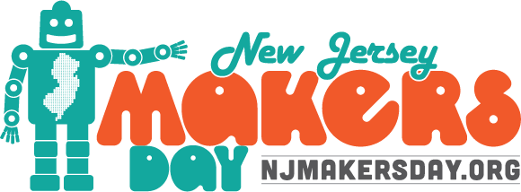

[Your Name]
[Address]
[City], NJ [Zip Code]

[Date]

[Legislator Name]
[Address]
[City], NJ [Zip Code]

Dear [Mayor/Assembly Member/Senator] (Last name):
My name is [your first and last name], [position] at [organization]. I’d like to introduce you to an upcoming statewide event highlighting STEM learning and maker culture in which [organization] will be participating! This year is the sixth annual New Jersey Makers Day (www.njmakersday.org), and [organization] is hosting special events on March [date(s)]. I would like to personally invite you and/or members of your staff to join us this March to experience not only what New Jersey Makers Day is all about, but to also see all the innovative education and play happening at [organization]. [Include a sentence about any relevant attendance numbers or specific highlights from your organization’s previous NJMD events here.]

Our goal through participating in New Jersey Makers Day is to celebrate our entire community and its role in the culture of making in the state. The maker movement is having a significant impact on school curriculum development and growing local economies, and to this end, [organization] has planned an engaging lineup of programs for [all ages/kids/teens/adults]. [In this space, include any programs, demonstrations, or local partnerships you would like to highlight.]

Find out more at [website] or feel free to contact [name] at [telephone/email].

We hope you can make it to [organization] on [date] to help us celebrate making and maker culture in our community!
Sincerely,
[Name]
[Organization]

